|  |  |
| --- | --- |
| **TUESDAY, JUNE 14, 2022** | |
| **7:30 AM** | **Hosted Buffet Breakfast, Registration check-in** |
| **7:50 AM** | **MODERATOR: MICHELLE WEST** |
| **7:55 AM** | **Jim Kelley, Emotion Trac** |
| **8:00 AM** | **Larry Simon, New York, NY** *“Successful Initial Investigation/Evaluation of Trucking Cases”* |
| **8:20 AM** | **Leslie Brueckner, Oakland, CA** *“Murderers, Scoundrels, and Thieves: Update on Efforts by Mass Tortfeasors to Get Out of Jail Free”* |
| **8:40 AM** | **Bradley Wallace, Encino, CA**  *“Thoughts & Strategy for Mini-Openings”* |
| **9:00 AM** | **Max Effatian & Kevin Parhm, Alert Communications** |
| **9:07 AM** | **Micha Star Liberty, Oakland, CA** *“Trauma Informed Litigation”* |
| **9:27 AM** | **Denisse Gastelum, Los Angeles, CA** *“Litigating Civil Rights/Police Misconduct Cases: Police Shootings & Jail Deaths”* |
| **9:47 AM** | **MODERATOR: BRADLEY ELLEY** |
| **9:52 AM** | **Nick Coccimiglio, Justice for Life** |
| **10:02 AM** | **Christian Jagusch, San Francisco, CA**  *“The New MICRA: Maximizing Recovery”* |
| **10:32 AM** | **Brent Barton, Newport, OR**  *“Cross-Examining Experts: Lessons from Oregon’s Trial by Ambush”* |
| **10:52 AM** | **Darryl Isaacs, Louisville, KY**  *“Using Advertising to get Million Dollar Cases”* |
| **11:12 AM** | **Steve Brady, San Rafael, CA**  *“Winning Every Trial with Animations”* |
| **11:32 AM** | **Dorothy Clay Sims, Ocala, FL**  *“How to prepare for and cross examine defense experts by Decimating Dumb Defenses”* |
| **12:17 AM** | **END OF DAY** |
|  |  |
| **WEDNESDAY, JUNE 15, 2022** | |
| **7:30 AM** | **Hosted Buffet Breakfast, Registration check-in** |
| **7:50 AM** | **MODERATOR: DON SLAVIK** |
| **7:55 AM** | **Bob Caracciolo, Physician Life Care Planning** |
| **8:02 AM** | **Stuart Chandler, Fresno, CA**  *“Practical Tips for Handling UIM Claims”* |
| **8:22 AM** | **Yvonne Flaherty, Minneapolis, MN**  *TBD* |
| **8:42 AM** | **William Green, San Rafael, CA**  *“Visual Storytelling for Mediation and Trial”* |
| **9:02 AM** | **Michelle West, Newport Beach, CA**  *“Defective Automobiles: Airbags”* |
| **9:22 AM** | **George McLaughlin, Denver, CO**  *“Pressure Cooker Explosion Cases”* |
| **9:42 AM** | **Rebecca Langston, Jackson, MS**  *“Lessons We’ve Learned: Arbitration - the Do’s & Don’ts”* |
| *Wednesday continues on next page* | |

|  |  |
| --- | --- |
| **SUNDAY, JUNE 12, 2022** | |
| **EVENT Registration Reception: Wailana Garden, Fairmont Orchid 5:30 – 7:00 PM** | |
|  | |
| **MONDAY, JUNE 13, 2022** | |
| **7:30 AM** | **Hosted Buffet Breakfast, Registration check-in** |
| **7:50 AM** | **MODERATOR: CASEY JOHNSON, PRESIDENT-ELECT** |
| **7:55 AM** | **Susan Lawrence, People Hunter** |
| **8:02 AM** | **Bruce Stern, Lawrenceville, NJ** *"Mild Traumatic Brain Injury Is Not So Mild"* |
| **8:22 AM** | **John Bey, Atlanta, GA** *“Talking to Juries in 2022 and Beyond”* |
| **8:42 AM** | **Ben Dominguez, Houston, TX** *“Product Liability - Construction Secrets”* |
| **9:02 AM** | **Doug Arnest, 360 Financial** |
| **9:12 AM** | **Jennifer Fiore, San Francisco, CA** *“Quick Hits - Elder Abuse, New Laws & More”* |
| **9:32 AM** | **Arthur Bryant, Oakland, CA** *“Title IX’s 50th Anniversary: Time for Female Athletes to Sue”* |
| **9:52 AM** | **Steve Buser, Columbia, IL** *“The Nursing Home Fall Case”* |
| **9:59 AM** | **MODERATOR: JOHN LEADER** |
| **10:04 AM** | **Richard Abi-Rached, HMR Servicing, LLC** |
| **10:11 AM** | **Daniel Robinson, Newport Beach, CA** *“Recent Developments in Data Breach Litigation”* |
| **10:31 AM** | **Lauren Wood, Camarillo, CA** *“How to Get an Educational Program Approved for MCLE”* |
| **10:51 AM** | **ETHICS PANEL**  **Thomas Dempsey, Santa Monica, CA**  *“Unconscious or Implicit Bias that is Contrary to Legal Ethics”*  **Matthew Kita, Dallas, TX**  *“What Lawyers Can Learn from the Life of John Lennon”*  **Lish Whitson, Seattle, WA**  *“Rules of Professional Conduct 8.3 – Everywhere but California”* |
| **11:51 AM** | **Dr. Nancy Grugle, Exigent** |
| **11:56 AM** | **Jeff Bogert, Los Angeles, CA**  *“CCP -128.5 “WTH” New Defense Tactic”* |
| **12:16 PM** | **END OF DAY** |
| **EVENT President’s Welcome Reception: Coconut Grove, Fairmont Orchid 5:00 - 6:30 PM** | |

|  |  |
| --- | --- |
| **10:02 AM** | **MODERATOR: ROBERT CARTWRIGHT** |
| **10:07 AM** | **Dan Ambrose, Trial Lawyers University** |
| **10:12 AM** | **Thomas Brandi, San Francisco, CA**  *“Dos and Don'ts of Final Argument”* |
| **10:32 AM** | **Jeff Mitchell, San Francisco, CA**  *“The Absolute Importance of Screening of Medical Malpractice Cases”* |
| **10:52 AM** | **Anna Dubrovsky, San Francisco, CA**  *“Shall we call an Uber?”* |
| **11:12 AM** | **Matthew Kimmins, Trial Template** |
| **11:17 AM** | **Ronald Foreman, San Francisco, CA**  *“The Hidden Gem - Cartwright Act Remedies”* |
| **11:37 AM** | **Randall Scarlett, San Francisco, CA**  *“Frontal/Temporal Lobe Damage: Your Worse Nightmare”* |
| **11:57 AM** | **Jeffrey Phillips, Phoenix, AZ**  *“Employee Retention Tax Credit”* |
| **12:17 AM** | **END OF DAY** |
| **EVENT Luau Dinner and Entertainment: Croquet Lawn, Fairmont Orchid 6:00 - 9:00 PM** | |
|  | |
| **THURSDAY, JUNE 16, 2022** | |
| **7:30 AM** | **Hosted Buffet Breakfast, Registration check-in** |
| **7:50 AM** | **MODERATOR: MICHA STAR LIBERTY** |
| **7:55 AM** | **Scott Greene, Evidence Solutions** |
| **8:00 AM** | **Corrie Yackulic, Seattle, WA**  *“Cities, Counties & States Fighting to Hold Fossil Fuel Giants Accountable for Climate Damages”* |
| **8:20 AM** | **Don Slavik, Steamboat Springs, CO**  *“Avoiding Snap Removal to Federal Court”* |
| **8:40 AM** | **Casey Johnson, Santa Ana, CA**  *“COVID Changed the Game Forever: Adapt or Get Left Behind”* |
| **9:00 AM** | **Fred Schultz, Bloomington, IN**  *“Jury Selection in Tough Liability Cases”* |
| **9:20 AM** | **Mike Gatto, Walnut Creek, CA**  *“Advanced Cross Examination Ideas”* |
| **9:40 AM** | **MODERATOR: THOMAS DEMPSEY** |
| **9:45 AM** | **Amanda Yawornicky, MSA Meds** |
| **9:50 AM** | **John Leader, Tucson, AZ**  *“Roadway Design Cases – An Overview”* |
| **10:10 AM** | **Hon. Shondeana Morris, Decatur, GA**  *“Professionalism and Wellness of Lawyers”* |
| **10:40 AM** | **Joseph Camerlengo, Jacksonville, FL**  *“Hidden Paths to Recovery in Trucking CMV Cases”* |
| **11:00 AM** | **Daniel Selarz, Los Angeles, CA**  *“Keeping it Cool in the Courtroom”* |
| **11:20 AM** | **Zachary Smith, Ojai, CA**  *“Success at Mediation”* |
| **11:40 AM** | **John Denove, Los Angeles, CA**  *“The Use of Non-verbal Communication to Persuade the Jury”* |
| **12:00 AM** | **END OF DAY** |
| **EVENT Closing Reception: Croquet Lawn, Fairmont Orchid 6:00 - 7:30 PM** | |

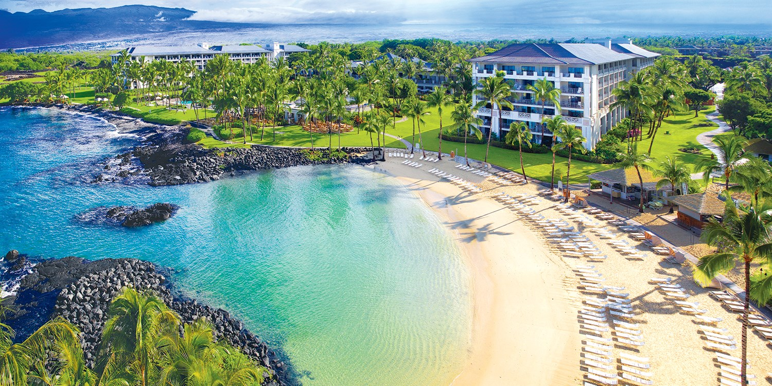



**SPEAKER SCHEDULE**

**2022 WTLA Hawaii Seminar**

**Fairmont Orchid**

**Big Island, Hawaii**

**June 13 – 16, 2022**